EC2 TASK
1. Launch one EC2 using Amazon Linux 2 image and add a script in user data to install Apache.
*create a new instance, apache-server
*add configuration ,security default,
*add script in additional settings, in user data option
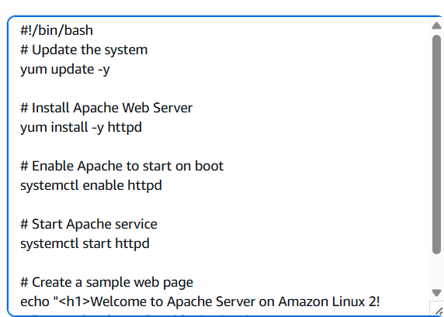
*now connect to linux machine by adding ssh -ip
*to verify – sudo systemctl status httpd
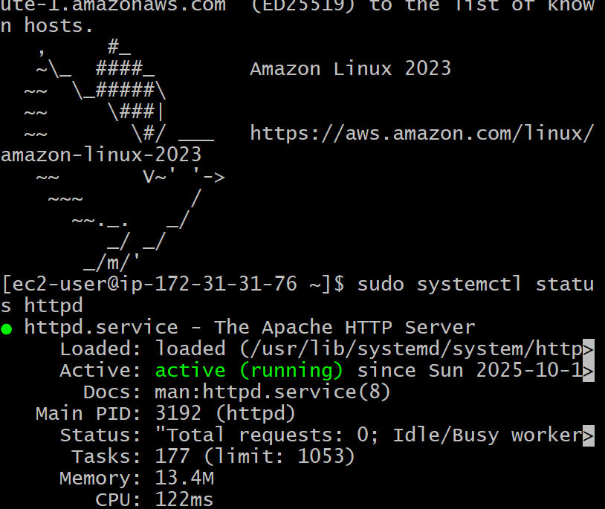

2. Launch one EC2 using Ubuntu image and add a script in user data to install Nginx.
*launch an instance in ec2 , using ami as ubuntu
*adding security rules
*enter install nginx script in additional pannel
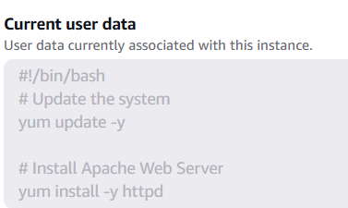
*now connect to instance using – pem key
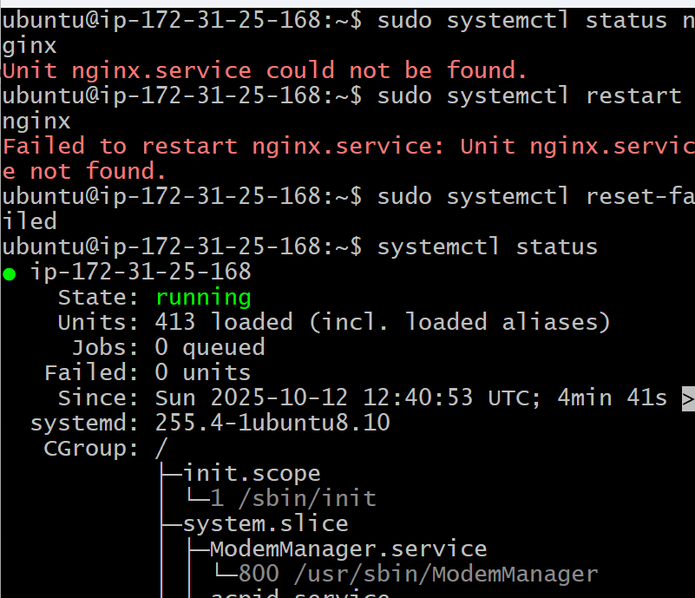
*check= sudo systemctl status

3. Launch one Windows server and install Tomcat on Windows.
*launch an instance called tomcat-server
*use windows

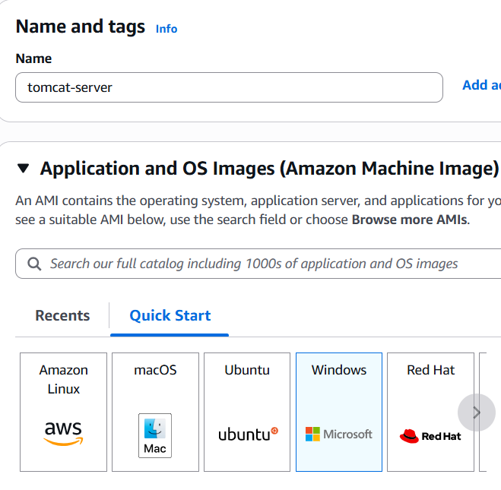
*network settings
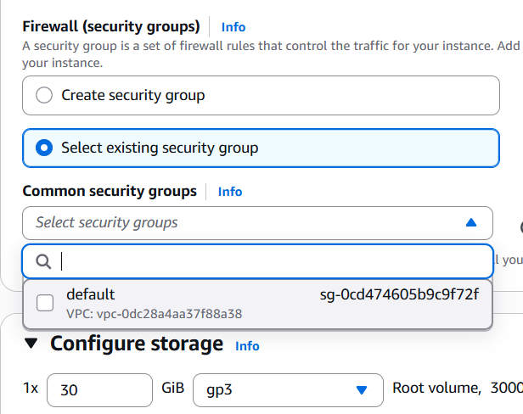
*added install tomcat script
*added pem.key file in rep endpoint
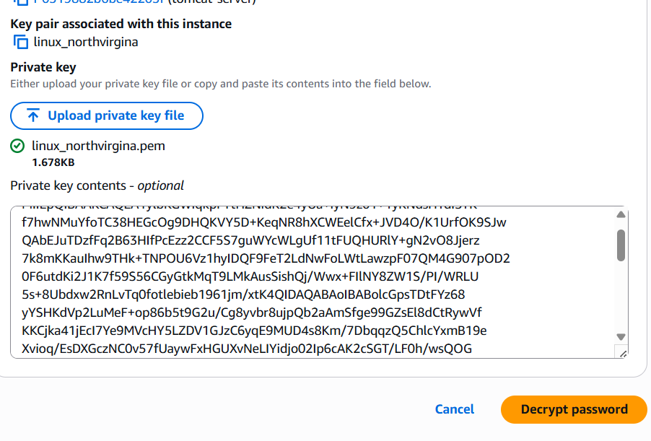
*connect using RDP
*upload pem.key
*create password , for administrator
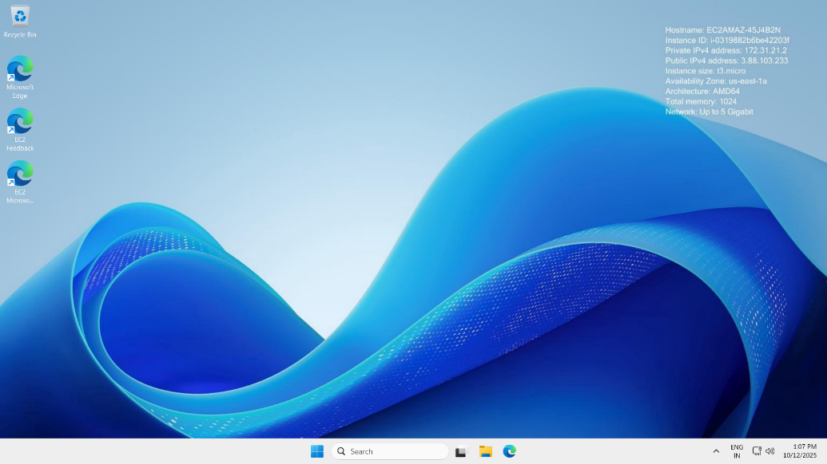
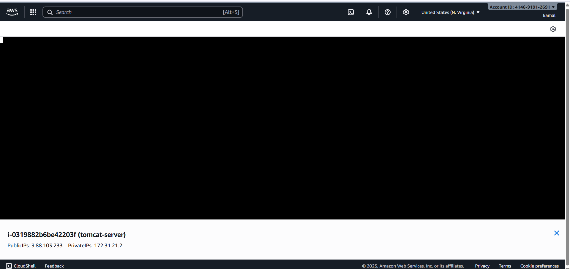

4. Take a snapshot of the instance created in Task 1.
*select the instance and go to storage coloumn
*now select the volume and
*check the actions
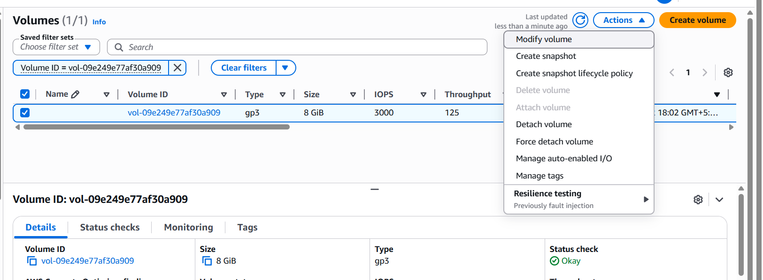
*create snapshot
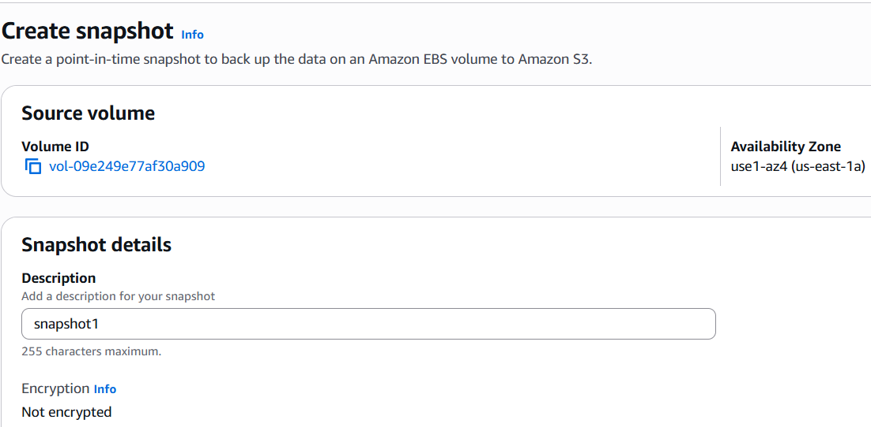
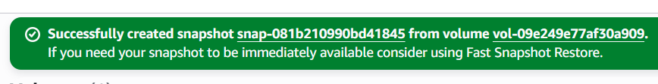
*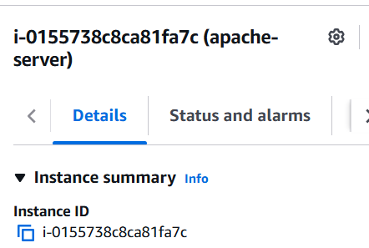
5. Assign passwordless authentication for the EC2 created in Task 2.
*ssh key-gen
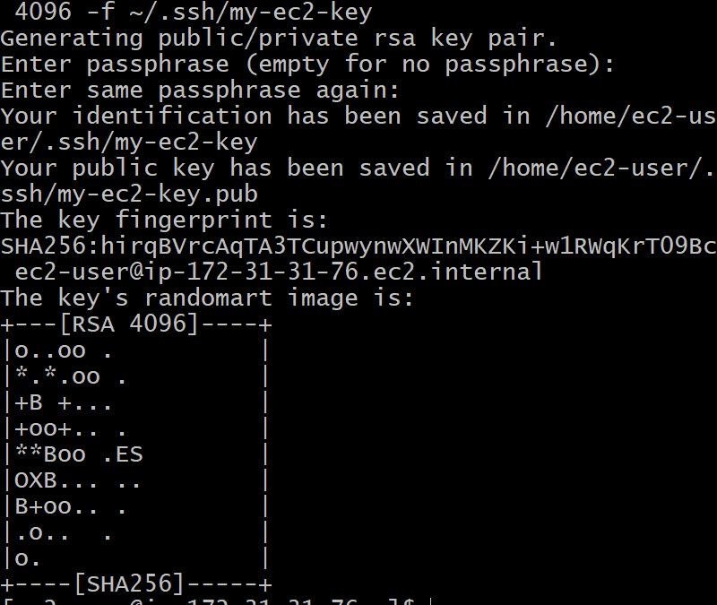
*list the keys created
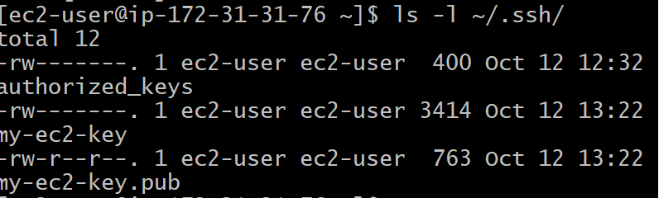
6. Launch any EC2 using the spot purchasing option.
*add spot request in additional user
*select maximum price
*request type one-time
*interruption behavious = terminate
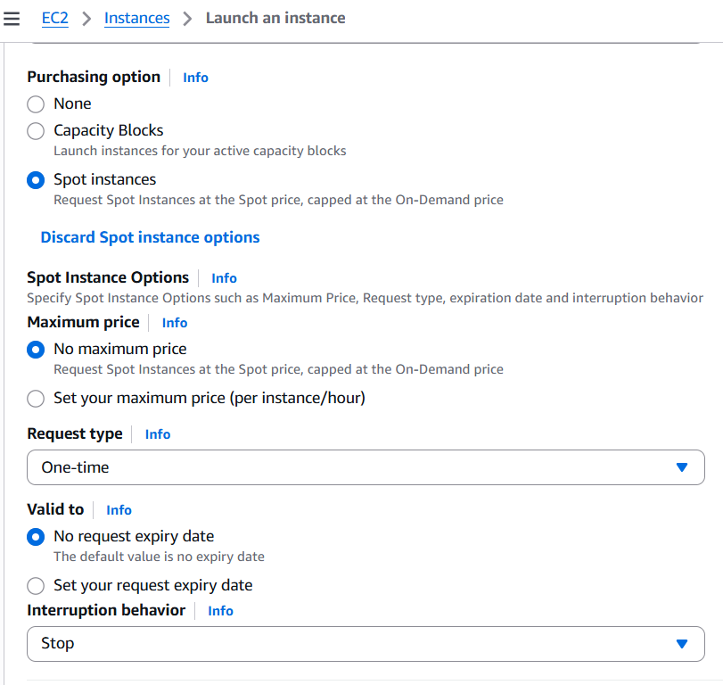
*instance launched succelsfully

7. Enable termination policy on the EC2 created in Task 2.
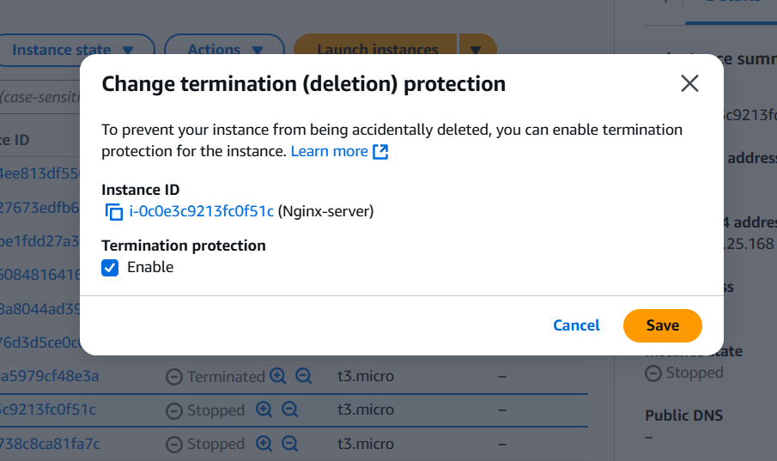

8.Launch one EC2 using AWS CLI.
*create a aws access key in GUI
*access key and password
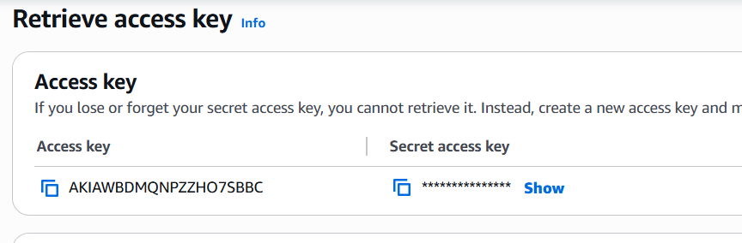
*configure cli and gui
*command = aws configure
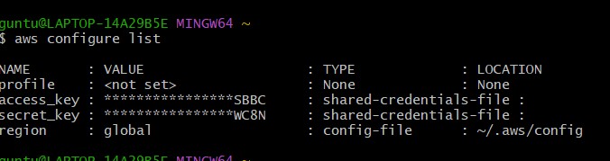
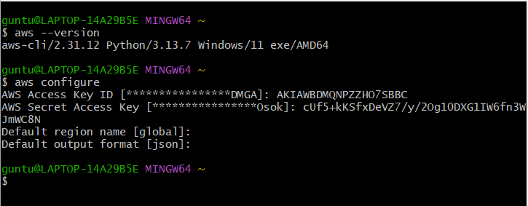
*list out the existing commands
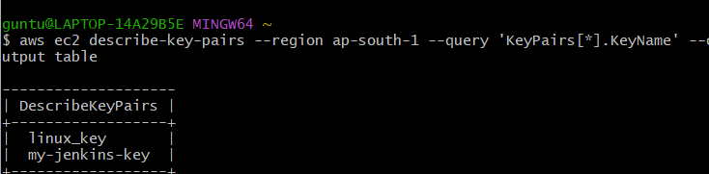
*run instance command
aws ec2 run-instances \
--region ap-south-1 \
--image-id ami-0dee22c13ea7a9a67 \
--instance-type t2.micro \
--key-name linux_key \
--count 1 \
--associate-public-ip-address
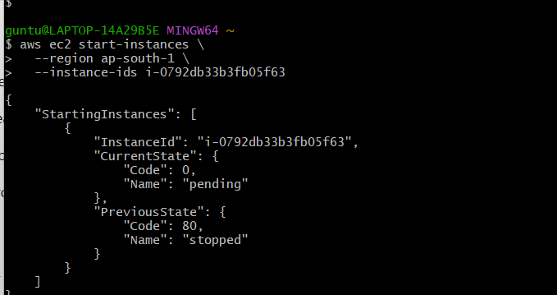
*to verify
aws ec2 describe-instances \
--region ap-south-1 \
--query "Reservations[*].Instances[*].[InstanceId,State.Name,PublicIpAddress]" \
--output table

*output
